Business Insights
1. Delivery Performance
- Observation: Delayed orders receive significantly lower review scores.
- Interpretation: Delivery speed is a critical driver of satisfaction.
- Recommendation:
  - Optimize logistics routes and warehouse operations.
  - Introduce proactive communication (SMS/email alerts) when delays occur.
  - Offer compensation (discounts, vouchers) for late deliveries to preserve trust.
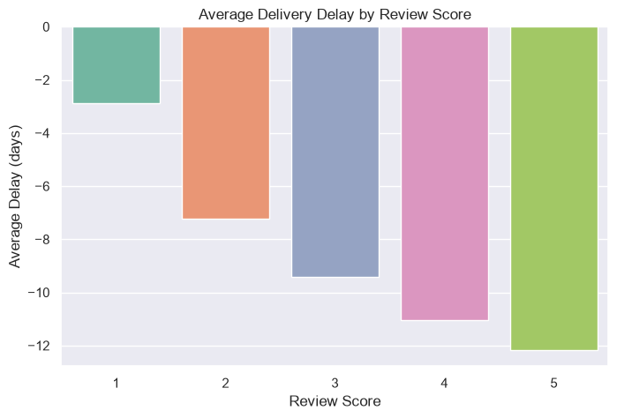

2. Product Category Spending
- Observation: Spending differs significantly across categories.
- Interpretation: Certain categories dominate revenue.
- Recommendation:
  - Prioritize inventory and stock levels for high-spending categories.
  - Bundle complementary products to increase basket size.
  - Experiment with dynamic pricing in top categories to maximize margins.
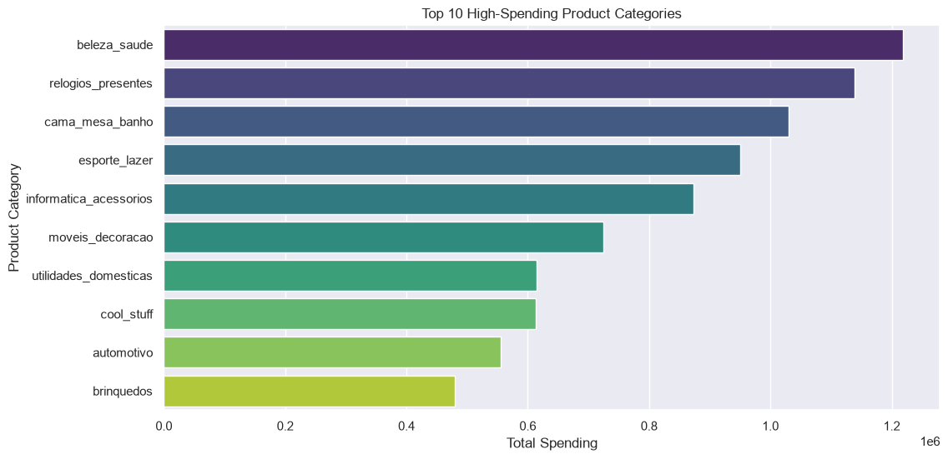

3. Payment Method vs Order Status
- Observation: Orders paid via bank slip show a noticeably higher rate of cancellations compared to card or voucher payments.
- Interpretation: Payment choice influences reliability. Bank slip functions similarly to COD — customers commit to the order but payment confirmation is delayed or fails, leading to cancellations. Prepaid methods (credit/debit card, voucher) are more reliable.
- Recommendations:
  - Incentivize prepaid methods (card, voucher) with loyalty points or cashback to encourage customers to shift away from bank slip.
  - Implement stricter verification for bank slip orders (e.g., faster payment confirmation, reminders to complete payment).
  - Adjust marketing spend by payment type — prioritize acquisition through prepaid channels to reduce wasted spend on orders that are more likely to cancel.
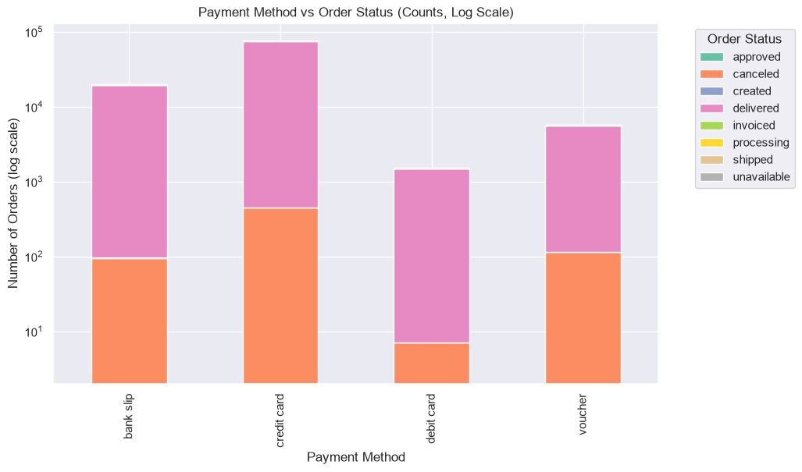
4. Seller Revenue Distribution
- Observation: Revenue is concentrated in certain states.
- Interpretation: Geographic imbalance in seller base.
- Recommendation:
  - Expand seller recruitment in underrepresented regions.
  - Provide training and incentives for small sellers in emerging markets.
  - Diversify supply chain to reduce dependency on a few states.
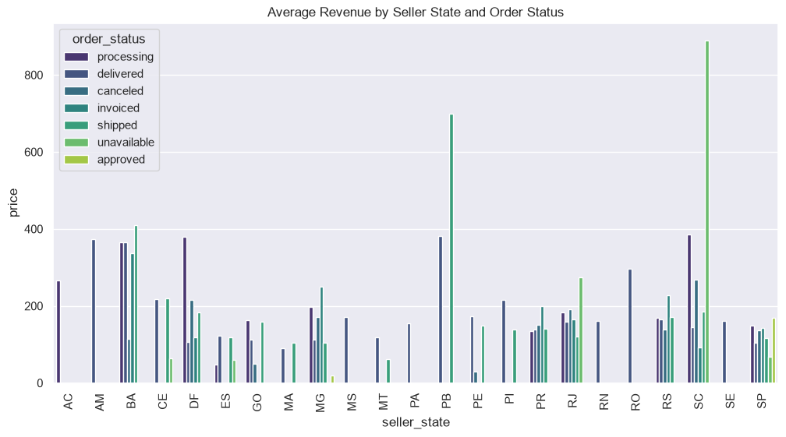
5. Seasonal & Temporal Trends
- Observation: Orders peak during weekends and festive seasons.
- Interpretation: Demand is time-sensitive and cyclical.
- Recommendation:
  - Scale delivery capacity during peak periods.
  - Run targeted promotions around festivals and weekends.
  - Align staffing schedules with demand spikes.
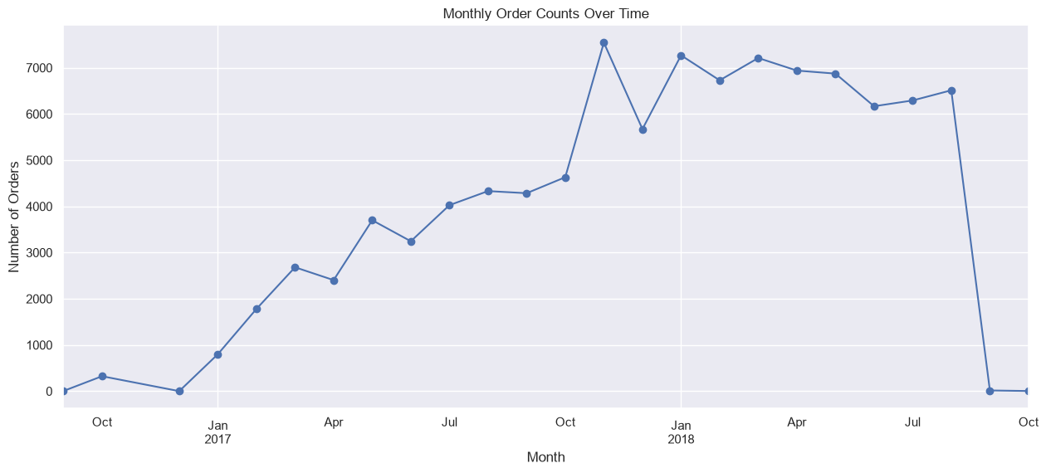

6. Freight Value & Costs
- Observation: Freight charges vary widely across orders.
- Interpretation: Logistics costs significantly impact profitability.
- Recommendation:
  - Negotiate better rates with courier partners.
  - Introduce free shipping thresholds to encourage larger baskets.
  - Optimize packaging to reduce freight costs.
